**CSM CHARLES L. ROBINSON III**

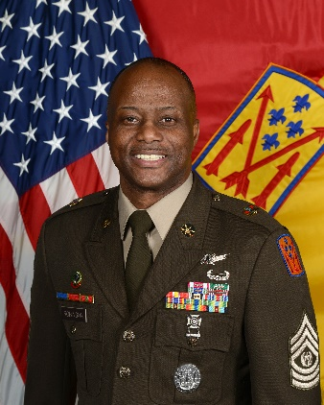Command Sergeant Major Charles Robinson III assumed responsibility of the newly activated 52d Air Defense Artillery Brigade in Sembach Kaserne, Germany, on 12 April 2023. Command Sergeant Major Robinson is a native of Miami, Florida. He graduated high school in June 1991, attended and graduated from Hampton University in 1998, with a Bachelor of Science in Aviation. He enlisted in the United States Army on August 21​st​, 2001. Upon completion of Basic Combat Training, CSM Robinson attended Advanced Individual Training at Fort Bliss, Texas and was awarded the MOS 14J.

Command Sergeant Major Robinson has held a variety of duty positions to include Battalion Command Sergeant Major, Operations Sergeant Major, First Sergeant, Detachment Sergeant, Platoon Sergeant, Senior Leader Course Instructor, Senior Instructor Advanced Leader Course, Operations Sergeant, JTAGS Crew Chief, Sentinel Section Sergeant, and Sentinel Crew Member.

Command Sergeant Major Robinson military education includes: Air Assault Course, Air Defense Computers and Intelligence Tactical Operation Center Enhanced Operator/Maintainer Course (14J), Master Resiliency Trainer Course, Master Driver Trainer Course, Modern Army Combatives Level I, Space Fundamentals Course, Multi-TADIL Advanced Joint Interoperability Course (MAJIC), Combat Life Saver Course, Basic Leader Course (BLC), Advanced Leader Course (ALC), Senior Leader Course (SLC), Sergeants Major Academy (SMC), Army Basic Instructor’s Course (ABIC), Small Group Instructor’s Training Course (SGITC), Brigade and Battalion Pre Command Course.

Command Sergeant Major Robinson’s duty assignments include: Headquarters and Headquarters Battery 4​th Battalion, 3​rd​ Air Defense Artillery Kitzingen, Germany; Headquarters and Headquarters Battery, 31​st​ Brigade, Fort Bliss, TX; Alpha Detachment 1​st​ Space Company, Stuttgart, Germany; Fires Center of Excellence Noncommissioned Officer Academy Fort Sill, OK; Alpha Battery 5​th​ Battalion, 7​th​ Air Defense Artillery Baumholder, Germany; 10th Army Air Missile Defense Command Kaiserslautern, Germany; Sergeants Major Academy, Fort Bliss, TX; Army Operational Test Command Fort Bliss, TX; Headquarters and Headquarters Battery 6th Battalion, 52nd Air Defense Artillery Suwon, Korea; Headquarters and Headquarters Battery 5th Battalion, 4th Air Defense Artillery Regiment.

His awards and decorations include: Meritorious Service Medal (4th OLC) Army Commendation Medal (7 OLC), Army Achievement Medal (2 OLC), Army Good Conduct Medal (7th Award), National Defense Service Medal, Iraq Campaign Medal (2 Campaign Stars), Global War on Terrorism Expeditionary Medal, Global War on Terrorism Service Medal, NCO Professional Development Ribbon (numeral 5), Army Service Ribbon, Overseas Service Ribbon (numeral 4), Armed Forces Service Medal, Meritorious Unit Award, and the Air Assault Badge.

Command Sergeant Major Robinson is a member of the Sergeant Audie Murphy Club and a member of the Honorable Order of St. Barbara.

Command Sergeant Major Robinson is married to Kristina Robinson and has three kids (Grace, Charles IV, and Reese).